[**DIGITAL SIGNAL & IMAGE PROCESSING LAB**](https://github.com/Amey-Thakur/DIGITAL-SIGNAL-AND-IMAGE-PROCESSING-AND-DIGITAL-SIGNAL-AND-IMAGE-PROCESSING-LAB)

[**EXPERIMENT -**](https://github.com/Amey-Thakur/DIGITAL-SIGNAL-AND-IMAGE-PROCESSING-LAB) **9**

**PART B**

(PART B: TO BE COMPLETED BY STUDENTS)

***(Students must submit the soft copy as per the following segments within two hours of the practical. The soft copy must be uploaded on the Blackboard or emailed to the concerned lab in charge faculties at the end of the practical in case there is no Blackboard access available)***

| **Roll No. 50** | **Name: AMEY THAKUR** |
| --- | --- |
| **Class: COMPS-BE-B-50** | **Batch: B3** |
| **Date of Experiment: 06/10/2021** | **Date of Submission: 06/10/2021** |
| **Grade :** |  |

**A.1 Aim:**

Write a program to perform Image Smoothing/ Image Sharpening.

**B.1 Software Code written by a student:**

* **Image Smoothening**

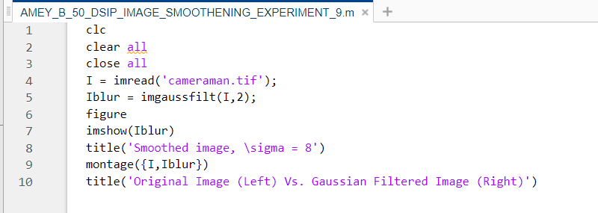

* **Image Sharpening**

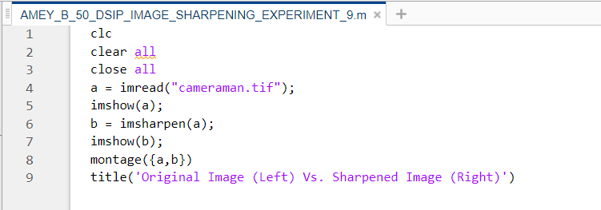

**B.2 Input and Output:**

* **Image Smoothening**

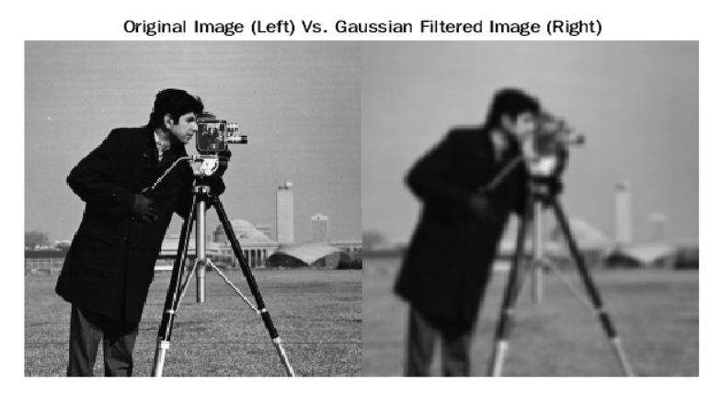

* **Image Sharpening**

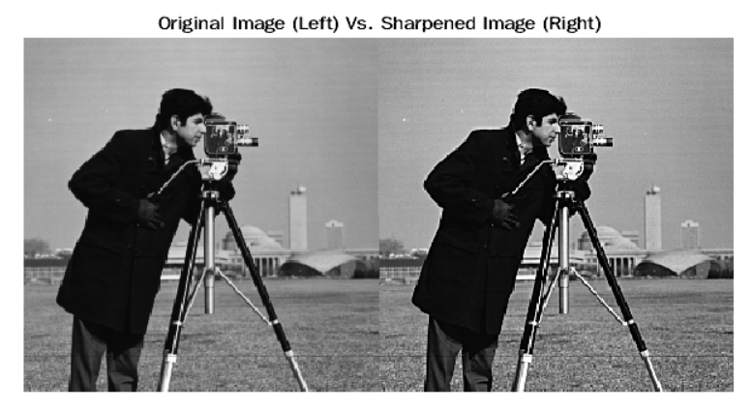

**B.3 Observations and learning:**

Smoothing and sharpening functions use the pixels in an N x N neighbourhood about each pixel to modify an image. For both smoothing and sharpening filters the larger the N x N neighbourhood the stronger the smoothing or sharpening effect.

**B.4 Conclusion:**

After successful completion of this experiment students will be able to Implement spatial domain Image enhancement techniques and we can write a program to perform Image Smoothing/ Image Sharpening.

**B.5 Question of Curiosity:**

1. What is Image Enhancement?

Ans:

Image enhancement is a subfield of digital image processing. The purpose of image enhancement is to improve the contrast and sharpen the image to enable further processing or analysis. It is the purpose of adjusting digital images so that the results are more suitable for display or further image analysis. For example, the removal of noise, sharpening or brightening an image, making it easier to identify key features. Image enhancement improves the quality and the information content of original data before processing. The enhancement does not raise the inbuilt information content of the data other than it increases the dynamic range of the selected facial appearance as a result that they can be detected.

1. Explain Image Smoothing and sharpening Filters?

Ans:

Image smoothing techniques have the goal of preserving image quality. In other words, to remove noise without losing the principal features of the image. However, there are several types of noise. The main three types are: impulsive, additive, and multiplicative.

* Impulsive noise is usually characterized by some portion of image pixels that are corrupted, leaving the others unchanged.
* Additive noise appears when the values of the original image have been modified by adding random values which follow a certain probability distribution.
* Multiplicative noise is more difficult to be removed from images than additive noise because in this case, intensities vary along with signal intensity.

Sharpening filters makes the transition between features more recognizable and obvious as compared to smooth and blurry pictures. Sharpening as the name suggests is used to sharpen and highlight the edges and make the transitioning of features and details more significant. However, sharpening doesn't take into account whether it is highlighting the original features of the image or the noise associated with it. It enhances both.